**Lapping the Living Room Questions**

1. 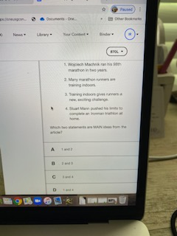

A 1 and 2

B 2 and 3

C 3 and 4

D 1 and 4

2. 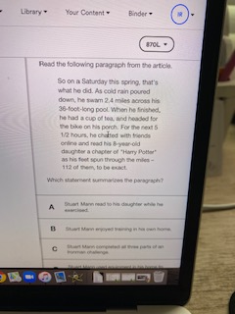

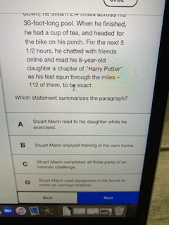

3. 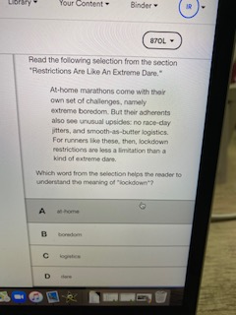

A at home

B boredom

C logistics

D dare

4. 